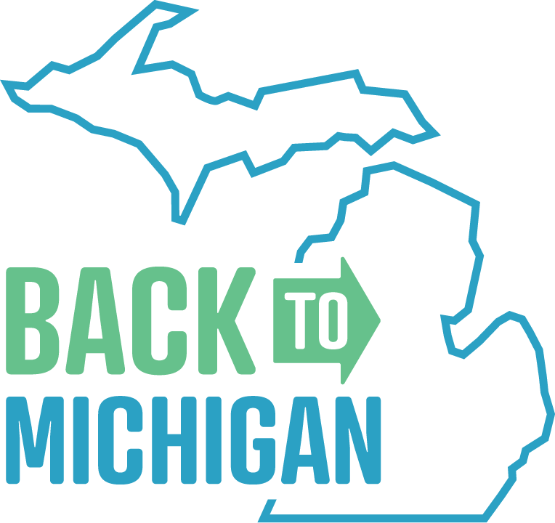
Suggested Facebook Posts and Tweets
Help us promote events around Michigan that help connect former Michigan residents with hiring employers. Your word-of-mouth helps us with registrations.
Locations:
- In-person: Ann Arbor, Detroit, Lansing, Mount Pleasant, Saginaw, West Michigan
- Virtual: Upper Peninsula
Website: “www.backtomichigan.com” but please https://bit.ly/37gDpcS in your posts because it is specific to you for tracking

Suggested Posts
Are you a Michigan native thinking about returning to the state? Cities all around the state are hosting virtual and in-person events for professionals who are coming back to Michigan for Thanksgiving. Consider relocation and find a new career opportunity in Michigan. https://bit.ly/37gDpcS
Miss your kids? If they’ve moved away and are coming back to Michigan for Thanksgiving, now is their chance to view relocation opportunities. Several events around Michigan give former residents the ability to meet with employers in a casual, online or in-person setting. Learn more: https://bit.ly/37gDpcS
Have all your college buddies moved away? Tell them it’s time to come back to Michigan! In the week leading up to the Thanksgiving holiday, former residents can participate in virtual, professional events happening across the state to meet with local hiring employers. Find out more: https://bit.ly/37gDpcS
Former Michigan resident? If you’ve been missing the Mitten, consider relocation by attending several events happening across the state. Meet local employers with current job opportunities virtually or face-to-face while you’re in town for Thanksgiving. Register now: https://bit.ly/37gDpcS
Want to move back to Michigan, but can’t find the right job? Check out virtual and in-person professional events leading up to Thanksgiving and meet with local hiring employers. Register now: https://bit.ly/37gDpcS
Are you a Michigan native thinking about coming back to the #ComebackState? Attend virtual or in-person networking events throughout the state where you can meet with hiring employers. Register at https://bit.ly/37gDpcS
Miss the Mitten? Make your holiday visits permanent and relocate! Network with hiring employers in Michigan while you’re in town for Thanksgiving. Learn more and register at https://bit.ly/37gDpcS
Did you know? Standing anywhere in the state of Michigan, you’re always within 85 miles of one of the Great Lakes. If you’re missing the Mitten state, it’s time to consider relocating! Attend online and in-person networking events around West Michigan to meet local employers and discover opportunities. Find more info: https://bit.ly/37gDpcS

Are you a true Michigander? If you’ve been missing home, consider making your visit permanent. Join a professional event around Thanksgiving and meet hiring employers to discover new opportunities in Michigan. Register at https://bit.ly/37gDpcS
Once a Michigander, always a Michigander. If you’re missing the days of living in the Great Lakes state, it’s time to come home. Connect with local employers to discover available opportunities during the Thanksgiving holiday. Find more info and participating locations at https://bit.ly/37gDpcS
With 3,288 miles of Great Lakes shoreline, there are always great views to admire in Michigan. And that’s just one reason to return home. Connect with local employers and discover opportunities in the Mitten state by checking out various networking events in Michigan. More info at https://bit.ly/37gDpcS
There are more than 11,000 inland lakes found throughout the state. If you’re missing the freshwater that the state has to offer, relocate back before the first day of summer! Learn about job opportunities by connecting with hiring employers at upcoming professional events. Sign-up at https://bit.ly/37gDpcS
Missing your friends from Michigan? Being the 10th most populous state in the nation, Michigan has plenty of opportunities for professional growth and creating new friendships. Learn about professional opportunities by connecting with employers at upcoming virtual networking events. Find info at https://bit.ly/37gDpcS
Suggested Tweets
Miss your kids? Let them explore relocation opportunities during casual, virtual and in-person networking events in Michigan. https://bit.ly/37gDpcS
College buddies moved away? Have them meet virtually with hiring employers leading up to Thanksgiving: https://bit.ly/37gDpcS
Miss the #Mitten? Make your holiday visits permanent & relocate! Find your next job at one of these online events: https://bit.ly/37gDpcS
Living outside of Michigan & looking to relocate here? Register for virtual, professional events & meet employers. https://bit.ly/37gDpcS
Visiting Michigan for Thanksgiving? Make the visit permanent & find a new job through these virtual events: https://bit.ly/37gDpcS
Find a new job, relocate, & be back in Michigan in time for the first beach day in 2024. https://bit.ly/37gDpcS

Missing the Michigan sunsets? Those are some of our favorite views, too. Make the move back home and never miss out on a beautiful evening view again. Network virtually with local employers while visiting home for the holiday. Find more info: https://bit.ly/37gDpcS
MI has the longest freshwater coastline in the US. Experience the beauty of the Great Lakes state and find job opportunities at various virtual, professional networking events throughout the month. Register at https://bit.ly/37gDpcS
There’s more to life in Michigan. Rediscover opportunities in the Mitten state by joining us at a professional, virtual networking event. Sign-up for free at https://bit.ly/37gDpcS
Want to sharpen those networking skills? Check out professional, virtual networking events available across the state during the Thanksgiving season. Register for free at https://bit.ly/37gDpcS
Coming home for the holidays? Make the stay permanent and discover opportunities in West Michigan. There will be several virtual networking events throughout the month of November. Find more info: https://bit.ly/37gDpcS

Images
