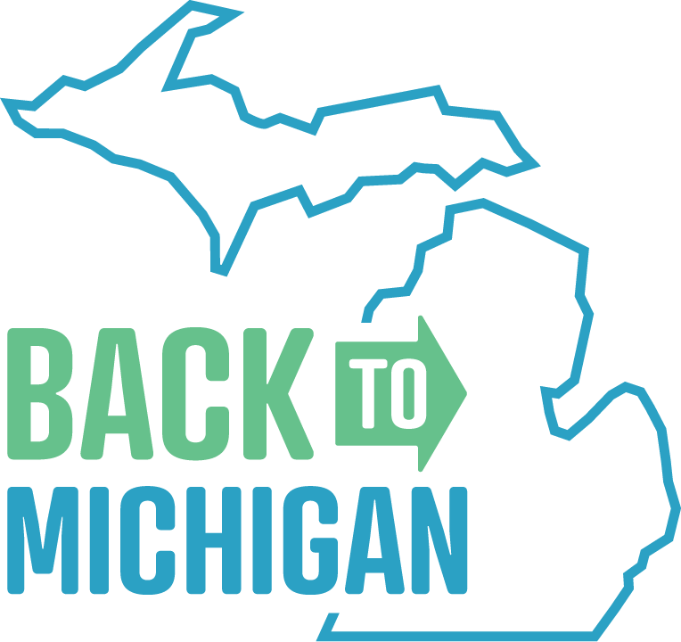
Suggested Facebook Posts and Tweets
Help us promote events around Michigan that help connect former Michigan residents with hiring employers. Your word-of-mouth helps us with registrations.
Locations:
- In-person: Ann Arbor, Detroit, Lansing, Mount Pleasant, Saginaw, West Michigan
- Virtual: Upper Peninsula
Website: “www.back2michigan.com” but please use https://bit.ly/2GYtqOm in your posts because it is specific to you for tracking

If you are looking for more localized messaging, please reach out to the location host in your region. Find them by visiting www.backtomichigan.com/sponsor.
Suggested Posts
Are you a Michigan native thinking about returning to the state? Cities all around the state are hosting virtual events for professionals who are coming back to Michigan for Thanksgiving. Consider relocation and find a new career opportunity in Michigan. https://bit.ly/2GYtqOm
Miss your kids? If they’ve moved away and are coming back to Michigan for Thanksgiving, now is their chance to view relocation opportunities. Several events around Michigan give former residents the ability to meet with employers in a casual, online setting. Learn more: https://bit.ly/2GYtqOm
Have all your college buddies moved away? Tell them it’s time to come back to Michigan! Near the Thanksgiving holiday, former residents can attend virtual, professional events in Michigan to meet with local hiring employers. Find out more: https://bit.ly/2GYtqOm
Missing your friends in Michigan? Being the 10th most populous state in the nation, Michigan has plenty of opportunities for professional growth and creating new friendships. Learn about professional opportunities by connecting with employers at this holiday’s networking event. https://bit.ly/2GYtqOm
Tell your friends that it’s time to move back to Michigan! If you have friends visiting this Thanksgiving, it’s now their chance to view relocation opportunities. They can connect with local employers with current job opportunities while in town. Find more info here: https://bit.ly/2GYtqOm
Former Michigan resident? If you’ve been missing the Mitten, consider relocation by attending several virtual events across the state. Meet local employers with current job opportunities while you’re in town for Thanksgiving. Register now: https://bit.ly/2GYtqOm
Want to move back to Michigan, but can’t find the right job? Check out virtual, professional events around Thanksgiving and meet with hiring employers. Register now: https://bit.ly/2GYtqOm
Are you a Michigan native thinking about coming back to the #ComebackState? Attend virtual networking events throughout the state where you can meet with hiring employers. Register at https://bit.ly/2GYtqOm.
Miss the Mitten? Make your holiday visits permanent and relocate! Network virtually with hiring employers in Michigan while you’re in town for Thanksgiving. Learn more and register at https://bit.ly/2GYtqOm
Did you know? Standing anywhere in the state of Michigan, you’re always within 85 miles of one of the Great Lakes. If you’re missing the Mitten state, it’s time to consider relocating! Attend virtual networking events around Michigan to meet with local employers and discover opportunities. Find more info: https://bit.ly/2GYtqOm

Are you a true Michigander? If you’ve been missing home, consider making your visit permanent. Attend virtual networking events around Thanksgiving and meet hiring employers to discover new opportunities in Michigan. Register at https://bit.ly/2GYtqOm
Once a Michigander, always a Michigander. If you are visiting this Thanksgiving and considering relocating back to Michigan, connect with local employers in a casual setting to learn about the current job opportunities they have while you are in town. Register here: https://bit.ly/2GYtqOm
Once a Michigander, always a Michigander. If you’re missing the days of living in the Great Lakes state, it’s time to come home. Connect online with local employers to discover available opportunities during the Thanksgiving holiday. Find more info and participating locations at https://bit.ly/2GYtqOm
Miss The Great Lakes and great times? If you’ve been missing home, consider your holiday visit permanent by joining a professional event on Thanksgiving Eve to meet local employers with opportunities in Michigan. Register here: https://bit.ly/2GYtqOm
With 3,288 miles of Great Lakes shoreline, there are always great views to admire in Michigan. And that’s just one reason to return home. Connect with local employers and discover opportunities in the Mitten state by checking out various virtual networking events in Michigan. More info at https://bit.ly/2GYtqOm
Miss Michigan’s warm sunsets by the lake? You don’t have to! Consider relocating and finding new job opportunities by attending several events happening across the state. Connect with local employers while you’re in town this holiday. https://bit.ly/2GYtqOm
There are more than 11,000 inland lakes found throughout the state. If you’re missing the freshwater that the state has to offer, relocate back before the first day of summer! Learn about job opportunities by connecting with hiring employers at upcoming virtual networking events. Sign-up at https://bit.ly/2GYtqOm
Suggested Tweets
Looking to work in Michigan? Come back to Michigan for Thanksgiving and meet with hiring employers during casual networking events. https://bit.ly/2GYtqOm
Miss your kids? Let them explore relocation opportunities during casual, virtual networking events in Michigan. https://bit.ly/2GYtqOm
College buddies moved away? Have them meet with hiring employers virtually while they’re back in town for Thanksgiving: https://bit.ly/2GYtqOm
Miss the #Mitten? Make your holiday visits permanent & relocate! Find your next job at one of these online events: https://bit.ly/2GYtqOm
Living outside of Michigan & looking to relocate here? Register for online professional events & meet employers. https://bit.ly/2GYtqOm
Visiting Michigan for Thanksgiving? Make the visit permanent & find a new job through these online events: https://bit.ly/2GYtqOm
Find a new job, relocate, & be back in Michigan in time for the first beach day in 2024. https://bit.ly/2GYtqOm

Missing the Michigan sunsets? Those are some of our favorite views, too. Make the move back home and never miss out on a beautiful evening view again. Network with local employers virtually while visiting home for the holiday. Find more info: https://bit.ly/2GYtqOm
MI has the longest freshwater coastline in the US. Experience the beauty of the Great Lakes state and find job opportunities at various professional networking events happening virtually throughout the month. Register at https://bit.ly/2GYtqOm
There’s more to life in West Michigan. Rediscover opportunities in the Mitten state by joining us at professional networking events virtually. Sign-up for free at https://bit.ly/2GYtqOm
Want to sharpen those networking skills? Check out virtual, professional networking events available during the Thanksgiving season. Register for free at https://bit.ly/2GYtqOm
Coming home for the holidays? Make the stay permanent and discover opportunities in Michigan. There will be several virtual networking events throughout the month of November. Find more info: https://bit.ly/2GYtqOm

Images
